Social Studies 20-1
- Nation, Nation-States and Internationalism
- Foreign Policy and Internationalism
ASSIGNMENT BOOKLET 3A

SENIOR HIGH SCHOOL
Fort Saskatchewan 780 992 0101
Sherwood Park 780 464 1899
Vegreville 780 632 7998

Assignment Booklet Questions Rubric 10-1/20-1/30-1

 | Excellent (5) | Proficient (4) | Satisfactory (3) | Limited (2) | Poor (1)
Communication:  Consider effectiveness of student’s:  - organization  - Syntax, mechanics, and grammar  - Use of vocabulary and Social Studies terminology | Writing is fluent and skillfully structured. Controlling idea effectively sustained and integrated. Skillfully control. Absence of error impressive. Precise, deliberate vocabulary. | Writing is clear and purposefully structured. Controlling idea coherently sustained and integrated. Capable control. Minor errors do not impede communication. Appropriate, specific vocabulary. | Writing is straightforward and functionally ordered. Controlling idea generally maintained. Basic control. Occasional lapses and minor errors, however generally clear. Conventional, adequate vocabulary. | Writing is awkward and lacks clarity. Controlling idea inconsistently maintained. Faltering control. Errors obscure the clarity of communication. Imprecise, simplistic vocabulary. | Writing is unclear and disorganized. Controlling idea is absent. Lack of control. Jarring errors impede communication. Overgeneralized, inaccurate vocabulary.
Interpretation & Analysis of Responses:  Consider how effectively the students:  - Critically analyze and demonstrate an understanding of the question | Insightful and sophisticated analysis and understanding of question. Perceptive, and comprehensively developed response. | Sound and adept analysis and understanding of question. Purposeful and capably developed response. | Straightforward and conventional analysis and understanding of question. Generalized and adequately developed response. | Analysis and understanding of question incomplete, lacks depth. Response is superficial and lacks development. | Minimal analysis and understanding of the question. Disjointed and vague response.
**IMPORTANT: Students are expected to complete ALL OF THE QUESTIONS in the assignment booklets. Booklets with less than 85% complete will be returned to the student for completion. **

Social Studies 20-1
Chapter 9: Nations, Nation-States and Internationalism
________________________________________________________
1. (Page 204) Fill in the missing information.
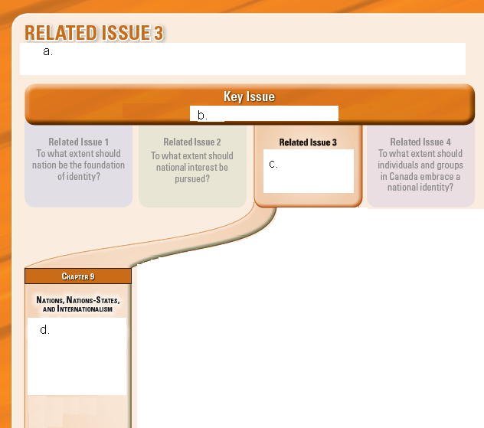

____

a.

b.

c.

d.

2. (Page 205) The Big Picture

As you explore this related issue, you will come to appreciate:

3. (Page 209) Chapter Issue

a) What is a nation-state?

b) Give four examples of nation-states.

c) (Page 209) Key Terms

Place the letter from the term in the box on the line beside its correct definition.
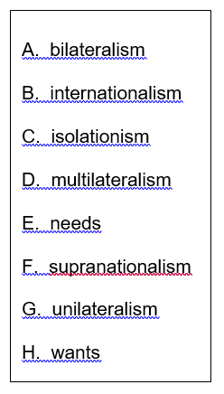
_____ a policy that involves several countries working together
to meet challenge and solve problems

_____ things that people desire, regardless of whether the
desired object contributes to their survival

_____agreements between two countries to work toward
resolving issues that concern both countries

_____the policy of a country responding to events on its own
without agreements with, or support from, other countries

_____the doctrine that all members of the global community
accept collective responsibility for the challenges that
face the world

_____ the basic elements—food, water, shelter, health—that
humans require for survival

_____a policy whereby a country completely ops our of
participating in international social, economic, political,
and military affairs

_____ a policy by which countries agree to abide by the decisions of an
international organization made up of independent officials or
representatives elected by member states

4. (Page 210) What are some common motives of nations and states?

a) What are 10 things you really don’t want to do?

b) Of the items you listed above, what are three that you end up doing anyway because
you need to do them for some reason? Explain why.

c) Use this organizer to explain how Maslow’s hierarchy of needs works
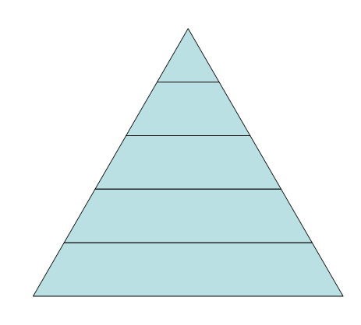
1
2
3
4
5
1.

2.

3.

4.

5.

5. (Page 211) Motives of Successful Nations and Nation-States

a) Just as the ________________________ of __________________________

is ________________________________ by a complex variety of needs and

wants, so, too, are the actions and actions of ____________________________

and ___________________________________________.

b) What four things that successful nation-states are often motivated by?

c) (Page 211) Economic Stability

Use a dictionary, or ask somebody what “economics” means, and write a definition of it here:

How can a country promote economic stability?

d) (Page 211) Figure 9-4

Fill in the missing information on this diagram, and explain how high employment can promote economic stability.


6. (Page 212) Peace and Security

Read the six paragraphs in this section, then respond to the questions below.

a) Why would countries co-operate with other nation-states?

b) Explain why or why not a country with a strong military—such as the United States—would be as strongly motivated to co-operate as those nation-states whose armed forces are smaller.

7. (Page 213) Self-Determination

a) Read the first four paragraphs of this section, then summarize the main idea of each paragraph in the chart below.

Summary of paragraph #1

Summary of paragraph #2

Summary of paragraph #3

Summary of paragraph #4


b) The Tagish and Tlingit successfully negotiated a self-government with Canada. This does NOT mean that they have broken away from Canada and become an independent nation-state. Choose two quotes that you liked from the Elders’ statement that you liked, and write them below.

8. (Page 214) Humanitarianism

a) What does humanitarianism mean? Use a dictionary or ask somebody if you are unsure?

b) Do an image search for the words“humanitarian aid.” Select one image that you liked, and paste it in the space below. Explain what kind of humanitarianism is happening in the image, and how humanitarianism meets needs and wants.

Explanation:

9. (Page 220 and 222) How do the motives of nations and states shape their responses to the world?

Explain the following motives of nations in their responses to the world and give examples from pages 218 and 220 to support your explanations.

isolationism

unilateralism

bilateralism

multilateralism

(Pages 218 and 220 continued)

supranationalism

10. (Page 221) Taking Turns

a) Summarize each of the three students’ responses to the question “Is isolationism a
valid response to world issues?”

Student | Summary
Rick

Blair

Pearl

b) How would you respond to the question that Rick, Blair, and Pearl are answering. Explain the reason for your response.

11. (Page 223) What are some understandings of internationalism?

a) What do Adams and Carfagna believe about internationalism?

ael Adams

J. Michael Adams


Carfagna
Angelo Carfagna

b) What is internationalism?

c) (Page 223) Voices

Why would Socrates be considered an internationalist?

d) To what extent do you consider yourself to be an internationalist?
Mark an X on the line below, then explain your reasons.

____________________________________________________________________
Little to not at all Lots

Explanation:

12. (Page 223-225)

Choose one of either The World Health Organization, or Right to Play, or The Arctic Council and summarize what it does. Then explain how this group supports the concept of internationalism.

13. (Page 226) How does internationalism benefit nations and states?

a) How did World War I and World War II promote internationalism?

b) (Page 226) Voices and Peace and Security

How is the United Nations supposed to prevent war, and has the United Nations functioned as Churchill thought it should?

c) (Page 226) Economic Stability

What is the purpose of the World Bank and the International Monetary Fund (IMF)?

What was the goal of the General Agreement on Tariffs and Trade (GATT)?

According to John Phiri, what is a serious problem with the WTO, IMF and the World Bank?

14. (Page 227) Indigenous Self-Determination and Humanitarianism

a) At the beginning of the 20th century

As the century unfolded, however

Use a dictionary or ask somebody, and write a definition to explain who
indigenous peoples are.

When indigenous peoples began demanding their rights for self-determination why do you think they were ignored?

How did indigenous peoples start the process to achieve their goals?

What are some examples of humanitarian organizations, and how do they promote internationalism?

Social Studies 20-1
Chapter 10: Foreign Policy and Internationalism
_______________________________________________________

15. (Page 230 and 231)
a) How is the monument, called “Reconciliation,” both a tribute to the purpose of peacekeeping, and a symbol of the Canadian cultural identity?
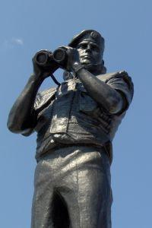

b) What is the Chapter Issue for chapter 10?

c) Why is the name of this monument significant?

What other names might have been on the list to be chosen for this monument?


Foreign Policy Notes
Download File

16. (Page 232) How do countries set foreign policy?

a) What does it mean for a country to have a foreign policy?

b) What is some evidence of Canada’s foreign policy in action?

17. (Page 232-233) Influences on Foreign Policy Decisions

a) Explain what the three government leadership styles are that make setting foreign policy relatively easy.

b) What makes setting foreign policy in democracies very complicated?

18. (Page 233) Foreign Policy Goals

Explain what would happen if Canada’s foreign policy goals were unclear.

19. (Page 234) The View from Here

Three people were asked the question “How much does the public influence the Canadian government’s foreign policy?”

a) In point form, summarize each of their speeches, and provide a quote from each person that you liked.

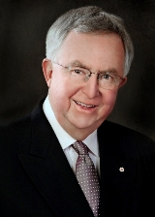  Joe Clark | (Image accessioned Oct 4, 2009 from: www.wilsoncenter. org/index. cfm?topic_id=1417)
 | Summary:
 | Quote:
  Bill Graham | (Image accessioned Oct. 4, 2009 from: http://www.mcgill.ca/files/humanrights)
 | Summary:
 | Quote:
  Wilfried von Bredow | (Image accessioned Oct. 4, 2009 from: www.bundeswehr.de/.../content.jsp)
 | Summary:
 | Quote:

b) Explain some similarities and differences between the person’s responses.

20. (Page 235) Foreign Policy in a Globalizing World

a) Why do you think there is a new trend in the reduced role played by nation-states in international affairs?

b) What do von Bredow and others believe about the changes brought about by globalization?

c) What is meant by the term domestic policy?

d) (Page 235 continued)

► International trade rules now ______________________ impact on labour,

environmental and other ______________________ framework policies.

►The implementation of ___________________________environmental obligations,

for instance, could have major _______________________ implications for

producers and _________________________ and impact on both

_________________________ and _______________________ governments.

►…foreign policy will by driven more than ever before by the __________________

demand for a better, ___________________ and fairer

________________________environment for __________________________.

e) (Page 235) Figure 10-4

Look at the image, and read the caption.
How is pollution in China—a domestic issue—also an international issue ?

21. (Page 236) How can states promote internationalism through foreign policy?

a) What is the careful balance that most countries try to achieve when setting their foreign policies?

22. (Page 236) Promoting Peace

a) Why is it controversial for countries to use their foreign policies to encourage struggling states to become successful and self-supporting?

b) What exactly are economic sanctions and why would a country use such strategies when trying to promote peace?

What is an example of how economic sanctions were used?

(Page 236) Voices

Who is truly hurt the most by economic sanctions?

23. (Page 237) Peacekeeping and Internationalism

What is the UN Security Council, and how does it protect collective security?

24. (Page 237) When and How Peacekeepers Are Used

a) The textbook tells us that “Peacekeepers are not peacemakers.” What is the difference between peacekeepers and peacemakers?

b) Why do you think troops involved in peacekeeping missions have to adhere to the guidelines listed in the textbook? Give examples of what would happen if they did NOT adhere to those guidelines.

25. (Page 238) Questioning the Role of Peacekeeping

What are some challenges that can cause a peacekeeping mission to fail? Use examples to support your explanation.

26. (Page 243) Foreign Aid and Internationalism

How does the delivering of foreign aid benefit both the receiver of the aid, and the sender of the aid?

27. (Page 244) The 0.7 Per Cent Solution

Explain why you think the 0.7 Per Cent Solution was a good idea or not.

28. (Page 244) Criticisms of Foreign Aid Policy

Explain what tied aid is and why this type of foreign aid policy is often criticized.

SUBMIT MODULE 3A TO BRIGHT SPACE AND THEN COMPLETE MODULE 3B

